**Computer Science 1600**

**Assignment 4 (Distance Section)**

**Spring 2019**

**DESIGN DOCUMENT**

**Part I – Designing the database – FILL-IN TABLES**

a).

|  |  |
| --- | --- |
| **Table Name** | **Description** |
| Book | Represents information about the book’s type, the tile, pages, publish year and ISBN number. |
| Publisher | Represents information about the publishing company, the location(city, country) of its head office, the email and phone number to contact. |
| Author | Represents information about the author’s name, gender, and the country where they come from. |
| Book-Store | Represents information about the on-off shelf date, both list price and sticker price of the book. |
| Evaluation | Represents information about the manager’s comments, the star rating of the book and the awards of the book. |

b).

|  |  |  |
| --- | --- | --- |
| **Entity 1** | **Entity 2** | **Cardinality of Relationship From Entity 1 to Entity 2** **(1:M, M:1 or 1:1)** |
| Book | Publisher | 1:1 |
| Author | Book | M:1 |
| Book | Book-Store | 1:M |
| Book | Evaluation | 1:M |

c).

Book(**ISBN**, **AID,** Type, Title, PageNum, Pyear)

Publisher(**CompanyID**, **ISBN,** CompanyName, OfficeCity, OfficeCountry, Email, Phone)

Author(**AID**, LName, FName, Gender, Country)

Book-Store(**BookStoreID**, **ISBN**, ListPrice, StickPrice, OnshelfDate, OffshelfDate)

Evaluation(**ISBN**, Comments, SRating, Awards)

d).

|  |  |  |  |
| --- | --- | --- | --- |
| **From Table** | **From Field** | **To Table** | **To Field** |
| Book | ISBN | Publisher | ISBN |
| Author | AID | Book | AID |
| Book | ISBN | Book-Store | ISBN |
| Book | ISBN | Evaluation | ISBN |

e).

|  |  |  |  |
| --- | --- | --- | --- |
| **Name** | **Type** | **Size** | **Description** |
| ISBN | Text | 13 | The 13-digit international standard book number that uniquely identifies a book. |
| AID | Text | 8 | The author that write the book |
| Type | Text |  | The type of the book it is e.g.travel, fiction... |
| Title | Text |  | The book’s title |
| PageNum | Number | 4 | The number of pages in the book. |
| Pyear | Number | 4 | The year that the book was first published |

**Part II – Implementing, modifying and using the designed database – SCREEN CAPTURES**

b). (iv.)

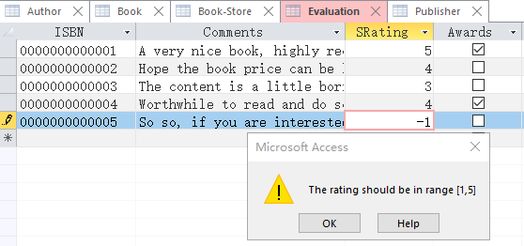

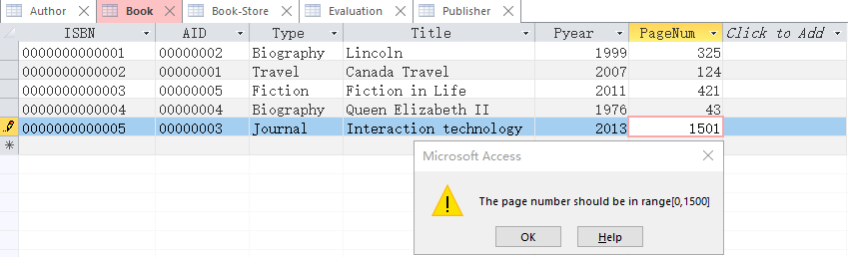

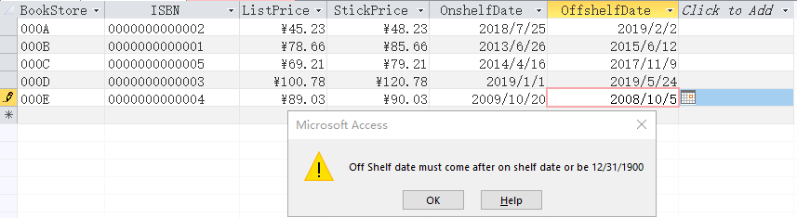

c).

